Use the labels from the list below to fill in the boxes:
Rows, Columns, Cell, Cell Reference

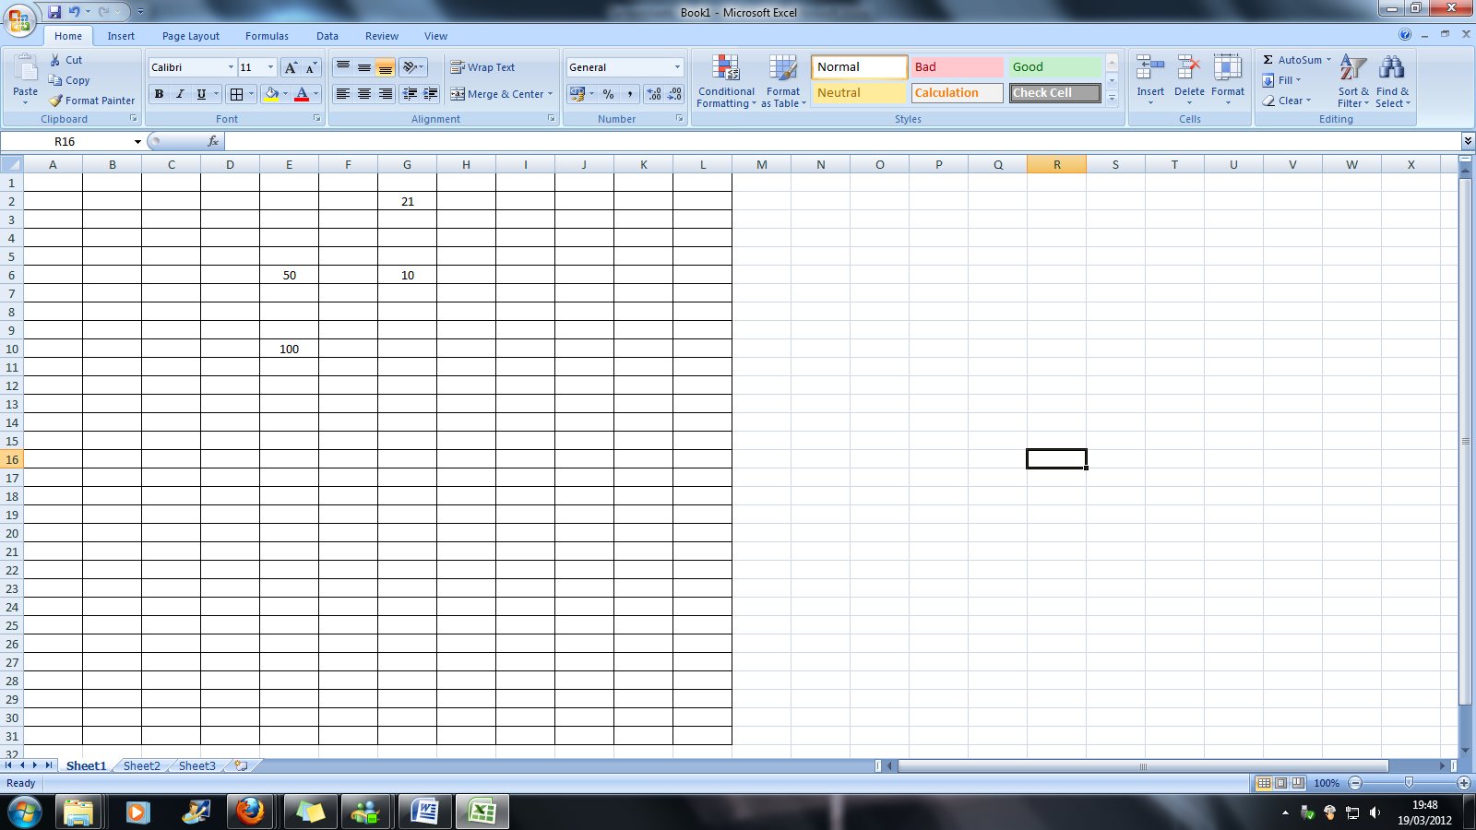
1.

2.

4.

3.

6. What is the value in cell E10? _____________
7. What is the value in cell G6? ______________

8. Which symbol do we use to multiply in a spreadsheet?
Circle your answer from the options below:
Answer: + \ * ()
9. Formulas in a spreadsheet (Microsoft Excel) always begin with ……………….
Answer: ________________________________________________________
10. Which function can we use to add data in a spreadsheet?
Answer: ________________________________________________________
11. What is the formula in cell N38?
Answer: _________________________________________
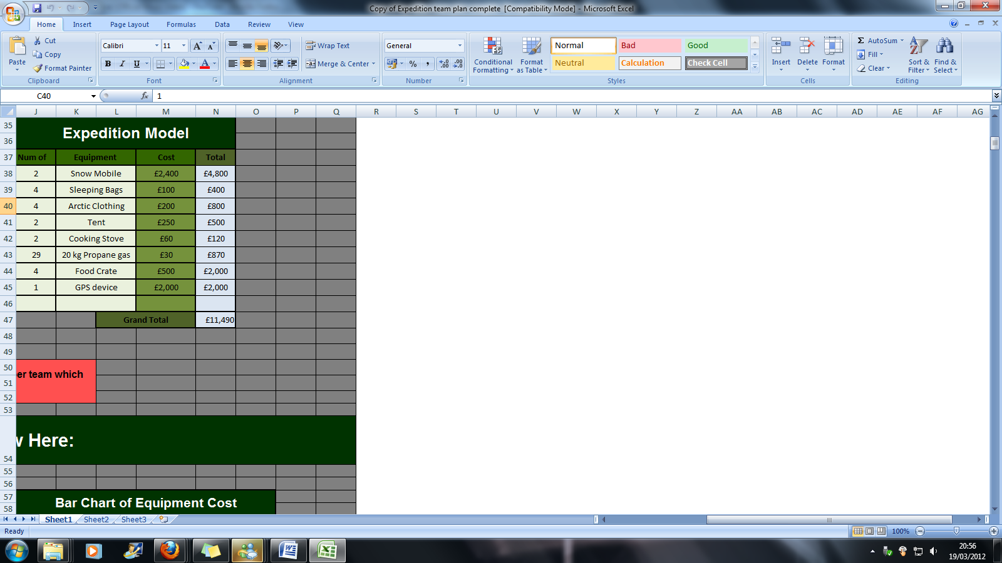

9. What is the formula to calculate the Grand Total in cell N47?
Answer: _________________________________________

